WORKSHEET
SQL (CS)
 | 1 | What are DDL and DML ? Give one command of each.
 | 2 | Which command is used to add new column in existing table?
 | 3 | Which clause is used to search for NULL values in any column?
 | 4 | Which command is used to see information like name of columns,datatype,size etc.?
 | 5 | Which clause is used for pattern matching? What are the 2 main characters used for matching the pattern?
 | 6 | Which clause is used to see the output of query in ascending or descending order?
 | 7 | Which clause is used to eliminate the duplicate rows from output?
 | 8 | What is the minimum number of column required in MySQL to create table?
 | 9 | Which command is used to remove the table from database?
 | 10 | Which command is used to add new record in table?
 | 11 | Which option of ORDER BY clause is used to arrange the output in descending order?
 | 12 | Which command is used to change the existing information of table?
 | 13 | Rajisa database programmer, He has to write the query from EMPLOYEE table to search for the employee whose name begins from letter„R‟,for this he has written the query as: SELECT* FROM EMPLOYEE WHERE NAME=‟R%‟;  But the query is not producing the correct output, help Raj and correct the query so that he gets the desired output.
 | 14 | Raj is a database programmer, He has to write the query from EMPLOYEE table to search for the employee who are not getting any commission, for this he has written the query as: SELECT * FROM EMPLOYEE WHERE commission=null;  But the query is not producing the correct output, help Raj and correct the query so that he gets the desired output.
 | 15 | Rajisa database programmer,has to write the query from EMPLOYEE table to search for the employee who are working in „Sales‟ or „IT‟ department, for this he has written the query as: SELECT*FROMEMPLOYEEWHEREdepartment=‟Sales‟or„IT‟;  But the query is not producing the correct output, help Raj and correct the query so that he gets the desired output.

TEACHER_CODE | TEACHER_NAME | DOJ
T001 | ANAND | 2001-01-30
T002 | AMIT | 2007-09-05
T003 | ANKIT | 2007-09-20
T004 | BALBIR | 2010-02-15
T005 | JASBIR | 2011-01-20
T006 | KULBIR | 2008-07-11

 | 16 | The following query is producing an error. Identify the error and also write the correct query.
 | 17 | If Table Sales contains 5 records and Raj executed the following queries; find out the output of both the query.  - Select 100+200 from dual;  - Select 100+200 from Sales;
 | 18 | What is the difference between Equi-Join and Natural Join?
 | 19 | Observe the given Table TEACHER and give the output of question(i)and(ii)  - SELECT TEACHER_NAME,DOJ FROM TEACHER WHERE TEACHER_NAME LIKE„%I%‟  - SELECT*FROM TEACHER WHERE DOJ LIKE„%-09-%‟;
 | 20 | Which SQL function is used to get the average value of any column?
 | 21 | What is the difference between COUNT()and COUNT(*)function
 | 22 | What is the full form of SQL?

 | 23 | Query to delete all record oftable without deleting the table:  - DELETE TABLE TABLE_NAME  - DELETE FROM TABLE_NAME  - DROP TABLE TABLE_NAME  - DELETE TABLE FROMTABLE_NAME
 | 24 | Identify the wrong statement about UPDATE command  - If WHERE clause is missing all there cord in table will be updated  - Only one record can be updated at a time using WHERE clause  - Multiple records can be updated at a time using WHERE clause  - None of the above
 | 25 | Identify the correct statement(s)to drop a column from table  - DELETE COLUMN COLUMN_NAME  - DROP COLUMN COLUMN_NAME  - ALTER TABLE TABLE_NAME DROP COLUMN COLUMN_NAME  - ALTER TABLE TABLE_NAME DROP COLUMN_NAME
 | 26 | Suppose a table BOOK contain columns (BNO, BNAME, AUTHOR, PUBLISHER), Raj is assigned a task to see the list of publishers, when he executed the query as:  SELECT PUBLISHER FROM BOOK;  He noticed that the same publisher name is repeated in query output. What could be possible solution to get publisher name uniquely? Rewrite the following query to fetch unique publisher names from table.
 | 27 | HOTS  Consider a database table T containing two columns X and Y each of type integer. After the creation of the table, one record (X=1, Y=1) is inserted in the table.  Let MX and MY denote the respective maximum values of X and Y among all records in the table at any point in time. Using MX and MY, new records are inserted in the table 128 times with X and Y values being MX+1, 2*MY+1 respectively. It may be noted that each time after the insertion, values of MX and MY change. What will be the output of the following SQL query after the steps mentioned above are carried out?  SELECTY FROM T WHER EX=7  A.127  B.255  C.129  D.257
 | 28 | Which SQL function is used to find the highest and lowest value of numeric and date type  column?
 | 29 | What is the default order of sorting using ORDERBY?
 | 30 | What is the difference between CHAR and VARCHAR?

 | 31 | Write SQL queries for (i)to (iv)and find outputs for SQL queries(v)to(viii)which are based on tables  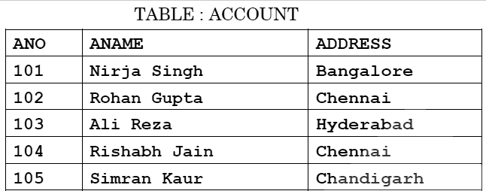  TABLE:TRANSACT  TRNO ANO AMOUNT TYPE DOT  T001 101 2500 Withdraw 2017-12-21  T002 103 3000 Deposit 2017-06-01  T003 102 2000 Withdraw 2017-05-12  T004 103 1000 Deposit 2017-10-22  T005 102 12000 Deposit 2017-11-06  - To display details of all transactions of TYPE Withdraw from TRANSACT table  - To display ANO and AMOUNT of all Deposit and Withdraw also done in month of  „May‟2017 from table TRANSACT  - To display first date of transaction (DOT) from table TRANSACT for Account having ANO as 102  - To display ANO, ANAME, AMOUNT and DOT of those persons from ACCOUNT and TRANSACT table who have done transaction less than or equal to 3000  - SELECTANO,ANAMEFROMACCOUNT  WHEREADDRESSNOTIN('CHENNAI','BANGALORE');  - SELECTDISTINCTANOFROMTRANSACT  - SELECTANO,COUNT(*),MIN(AMOUNT)FROMTRANSACT GROUP BY ANO HAVING COUNT(*)> 1  - SELECT COUNT(*), SUM(AMOUNT) FROM TRANSACTWHERE DOT <= '2017-10-01'

 | 32 | Consider the following tables EMP and SALGRADE, write the query for(i)to(vi)and output
 |  | for(vii)to(x)
 |  | TABLE:EMPLOYEE
 |  | ECODE NAME DESIG SGRADE DOJ DOB
 |  | 101 Vikrant Executive S03 2003-03-23 1980-01-13
 |  | 102 Ravi Head-IT S02 2010-02-12 1987-07-22
 |  | 103 JohnCena Receptionist S03 2009-06-24 1983-02-24
 |  | 105 AzharAnsari GM S02 2009-08-11 1984-03-03
 |  | 108 PriyamSen CEO S01 2004-12-29 1982-01-19
 |  | TABLE:SALGRADE
 |  | SGRADE SALARY HRA
 |  | S01 56000 18000
 |  | S02 32000 12000
 |  | S03 24000 8000
 |  | (i) To display details of all employee in descending order of their DOJ
 |  | - To display NAME AND DESIG of those employees whose grade is either„S02‟or
 |  | „S03‟
 |  | (iii) To display NAME,DESIG,SGRADE of those employee who joined in the year 2009
 |  | (iv) To display all SGRADE, ANNUAL_SALARY from table SALGRADE [where
 |  | ANNUAL_SALARY=SALARY*12]
 |  | (v) To display number of employee working in each SALGRADE from table EMPLOYEE
 |  | (vi) To display NAME, DESIG, SALARY, HRA from tables EMPLOYEE and SALGRADE
 |  | Where SALARY is less than 50000
 |  | (vii) Select MIN(DOJ),MAX(DOB)from employee;
 |  | (viii) Select SGrade, Salary + HRA from SalGrade where Sgrade=‟S02‟
 |  | (ix) Select count(distinct grade)from employee
 |  | (x) Select sum(salary),avg(salary)from salgrade

 | 33 | 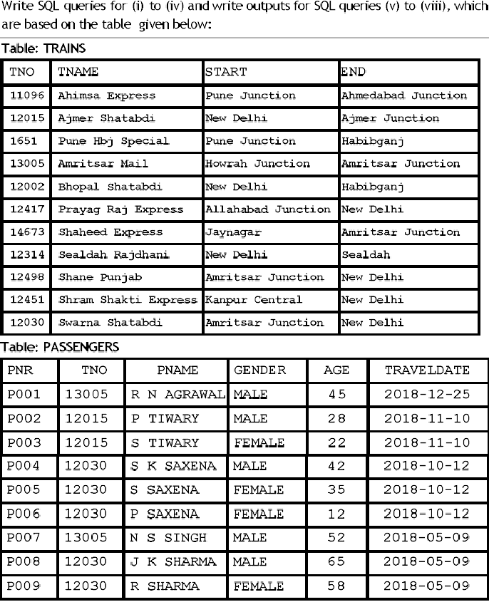  - To display details of all Trains which starts from New Delhi  - To display PNR, PNAME, GENDER and AGE of all passengers whose AGE is below 50  - To display total numbers of MALE and FEMALE passengers  - TodisplayrecordsofallpassengerstravellingintrainswhoseTNOis12015  - SELECT MAX(TRAVELDATE),MIN(TRAVELDATE) FROM PASSENGERS WHERE GENDER=‟FEMALE‟;  - SELECTEND,COUNT(*)FROMTRAINSGROUPBYENDHAVINGCOUNT(*)>1;  - SELECTDISTINCTTRAVELDATEFROMPASSENGERS;  - SELECT TNAME, PNAME FROM TRAINS T, PASSENGERS P WHERE T.TNO=P.TNO AND AGE BETWEEN 50 AND 60

 | 34 | ConsiderthetableSHOPPEandACCESSORIES,writethequeryfor(i)to(v)andoutputfor  (vi)to(x)  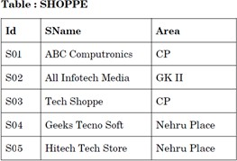

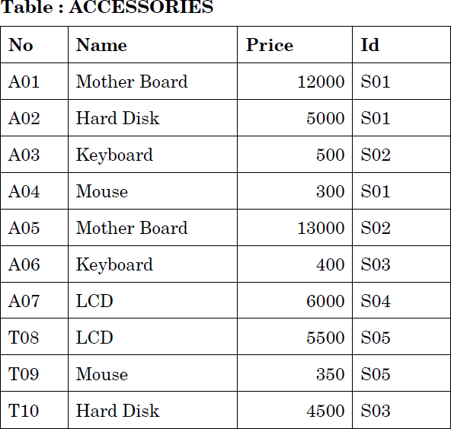

- To display Name and Price of all the Accessories in descending order of their Price
- To display Id and Sname of all the Shoppe location in„Nehru Place‟
- To display Name, Minimum and Maximum Price of each Name from ACCESSORIES table
- To display Name, Price of all Accessories and their respective SName from table SHOPPE and ACCESSORIES where Price is 5000or more.
- To display all details of accessories where name contains word„Board‟;
- SELECT DISTINCT NAME FROM ACCESSORIES WHERE PRICE>5000;
- SELECT AREA,COUNT(*) FROM SHOPPE GROUPBY AREA;
- SELECT AVG(PRICE),MAX(PRICE)FROM ACCESSORIES WHERE PRICE>=10000;
- SELECT NAME,PRICE*.05 DISCOUNT FROM ACCESSORIES WHERE ID IN(„S02‟,‟S03‟)
- SELECT * FROM SHOPPES,ACCESSORIES A WHERE S.ID=A.ID AND PRICE>=10000;

 | 35 | - In a database there are two tables:Write MYSQL queries for(i)to(iii)  Table:Item  ICode IName Price Color VCode  S001 MobilePhones 30000 Silver P01  S002 Refrigerator 20000 Cherry P02  S003 TV 45000 Black P03  S004 Washing Machine 12000 White P04 S005 Air Conditioner 50000 White P05 Table : Vendor  VCode VName  P01 Rahul  P02 Mukesh  P03 Rohan  P04 Kapil  - To display ICode, IName and VName of all the vendors, who manufacture “Refrigerator”.  - To display IName,ICode,VName and price of all the products whose price>=23000  - To display Vname and INamemanufactured by vendor whose codeis“P04”.
 | 36 | In a database there are two tables : Write MYSQL queries for (i) to (vi) Table : Doctors  DocID DocName Department NoofOpdDays  - JKMishra Ortho 3  - Maheshtripathi ENT 4  - RaviKumar Neuro 5  - MukeshJain Physio 3  Table: Patients  PatNo PatName Department DocId  - Payal ENT 102  - Naveen Ortho 101  - Rakesh Neuro 103  - Atul Physio 104  - To display PatNo, PatName and corresponding DocName for each patient.  - To display the list of all doctors whose No of Opd Days are more than 3  - To display DocName, Department,PatName and DocId from both the tables where DocID is either 101 or 103  - To display total no of different departments from Patients table.

VisitorID | VisitorName | Gender | ComingFrom | AmountPaid
1 | Suman | F | Kanpur | 2500
2 | Indu | F | Lucknow | 3000
3 | Rachana | F | Haryana | 2000
4 | Vikram | M | Kanpur | 4000
5 | Rajesh | M | Kanpur | 3000
6 | Suresh | M | Allahabad | 3600
7 | Dinesh | M | Lucknow
8 | Shikha | F | Varanasi | 5000

 | 37 | Given the Table “BANK” with records, Give the output of given queries–NAME  SACHIN RAMESH DINESH VIKAASH RAJU AMRITESH  - Select*from BANK where Name Like„%ES%‟;  - Select*from BANK where Name Like„ SH‟
 | 38 | RajeshadatabasedeveloperatStoreIndiawantstosearchtherecordofthoseemployees whosenamestartsfrom„R‟andtheyhavenotallottedanyproject,forthishehaswritten the following query-  Select*from Employee where Name=‘R%’ and Project=Null;  Butthequeryisnotproducingthecorrectoutput.Rewritethequeryaftercorrectingthe errors
 | 39 | ConsideringtheVisitortabledata,writethequeryfor(i)to(iv)andoutputfor(v)to(viii)  - WriteaquerytodisplayVisitorName,ComingFromdetailsofFemaleVisitorswith Amount Paid more than 3000  - Write a query to display all coming from location uniquely  - Write a query to insert the following values- 7, „Shilpa‟,‟F‟,‟Lucknow‟,3000  - WriteaquerytodisplayalldetailsofvisitorsinorderoftheirAmountPaidfrom highest to lowest  - Select Visitor Name from Visitor where Gender=‟M‟;  - Select AmountPaid+200fromVisitorwhereVisitorID=6;  - Select Sum(Amount Paid) from Visitor where coming From=‟Kanpur‟;  - Select Count(Visitor Name) from Visitor where Amount Paid is NULL;

 | 40 | Write a MySQL query to create the given table(MEMBER)
 |  |  | Columnname | Datatype | Size
 |  |  | ID | Char | 6
 |  |  | Name | Varchar | 30
 |  |  | Fee | Int | 10
 |  |  | DOJ | Date
 | 41 | What is the Difference between ALTER Table command and UPDATE command?
 | 42 | - Sanjay was deleting the record of empno=1234,but at the time of execution of command he forgot to add condition empno=1234,what will be the effect of delete command in this case?  - Sameerisexecutingthequerytofetchtherecordsofemployeewhoaregettingsalary between 4000 to 8000, he executed the query as -  Select * from employee where salary between 4000 to 8000; But he is not getting the correct output,Rewrite the correct 0query.
 | 43 | Write MYSQL command to see the list of tables in current database
 | 44 | Sunil decides to delete a Phone No column from a MySQL Table (student) after insert the data into the table. Write the command to delete that particular column in student table.
 | 45 | A table Employee contains 5Rows and 4Columns and another table PROJECTcontains 5 Rows and3Columns.How many rows and columns will be there if we obtain Cartesian  Product of these two tables?
 | 46 | Ranjeet created a table named student,He wants to see those students whose name ending with p. He wrote a query- SELECT * FROM student WHERE name=”p%”;  But the query is not producing the desired output,Help Ranjeet to run the query by removing the errors from the query and rewriting it.

EMPNO | ENAME | DEPT | SALARY | COMM
1 | ANKIT | HR | 20000 | 1200
2 | SUJEET | ACCOUNTS | 24000
3 | VIJAY | HR | 28000 | 2000
4 | NITIN | SALES | 18000 | 3000
5 | VIKRAM | SALES | 22000 | 1700

 | 47 | ConsiderthefollowingEMPLOYEEtablewriteMYSQLcommandfor(i)to(iv)andOutputsfor  (v)to(viii)  - To display the name of employees starting from„V‟in ascending order of their salary  - To display the details of all SALES dept employee who are earning salary more than 20000  - To count distinct department from the table  - Change the salary of NITIN from18000to20000  - To insert an row in the table Employee  „6‟,„SUMIT‟,‟HR‟,40000,2000  - Select AVG(COMM)from Employee  - Select ENAME, DEPT from Employee where Dept in(„HR‟,‟ACCOUNTS‟)  - Select ENAME,SALARY+100NEWSAL from Employee
 | 48 | Write MYSQL command to create the table ENQUIRY including its constraints  Table: ENQUIRY
 |  |  | Name of column | Type |  | Size |  | Constraints
 |  |  | visitorID | Decimal |  | 4 |  | Primarykey
 |  |  | visitorName | Varchar |  | 20
 |  |  | visitorMobile | Char |  | 10 |  | Notnull
 |  |  | visitorAddress | Varchar |  | 40
 | 49 | In a database there are two tables:  Table: Doctor
 |  |  | DocID |  | DocName |  | Specialist
 |  |  | D001 |  | VimalJha |  | Cardio
 |  |  | D002 |  | SunilBawra |  | Ortho
 |  |  | D003 |  | MukulBarman |  | Surgeon
 |  |  | D004 |  | NiteshSolanki |  | Skin

Table: Patient
PatID PatName DateAdm DocID
P001 Kapil 2013-10-10 D002
P002 Susheel 2013-09-01 D001
P003 Wasim 2013-10-15 D002
P004 Sanjay 2013-10-12 D003
P005 Jai 2013-10-17 D003

Write the MySQL queries for the following:
- To display PatID, PatName, and corresponding DocName of„Cardio‟and„Ortho‟ patient
- To display DocName, PatName of those patient who are admitted before15-Oct-2013
 | 51 | 1.WriteQueryforthefollowingrequirements– (STUDENT)  Id NAME STIPEND SUBJECT AVERAGE DIV  - KARAN 400 PHYSICS 68 1  - DIVAKAR 450 COMPSC 68 1  - DIVYA 300 CHEMISTRY 62 2  - ARUN 350 PHYSICS 63 1  - SABINA 500 MATHS 70 1  - JOHN 400 CHEMISTRY 55 2  - ROBERT 250 PHYSICS 64 1  - RUBINA 450 MATHS NULL NULL  - VIKAS 500 COMPSC 62 1  - MOHAN 300 MATHS 57 2  GUIDE  SUBJECT ADVISOR  PHYSICS ALOK  COMPSC RAJAN  CHEMISTRY MANJU  MATHS SMITA  HISTORY KISHORE  - TODISPLAYTHENAMEOFSTUDENT,SUBJECTANDADVISORNAME  - TODISPLAYTHESTUDENTNAMEANDADVISORALLTHESTUDENTSWHOAREOFFERING EITHER PHYSICS OR CHEMISTRY

 | 52 | DIFFERENCE BETWEEN  - HAVING AND WHERE  - %AND_  - CHAR AND VARCHAR

